*Merry Christmas*

# Christmas Luncheon

A combined Christmas luncheon for Wattle and Rivergum groups will be held at the Senior Citizens centre on Wednesday December 19. We will enjoy a traditional Christmas lunch, with all the trimmings, followed by local entertainment.

Time: 12.30pm

Luncheon Cost: $20.00

Transport: $2.50 each way

To ensure your place, could you please book and pay at Homecare by, no later than 14 December 2018.



Jarra Infusion - A place that brings community together Tuesday 11 December 2018

Jarra Infusion is a unique whimsical café nestled in the main street of Pinjarra. Food is locally sourced and predominantly handmade on premises whilst also supporting local small business that produce jams, pickles and diabetic deserts. Food on offer incorporates both interesting modern food whilst also having many traditional recipes.

Join us for a Christmas lunch with a quirky twist. HO HO HO!!

Pick-ups: Commence at 8.am Cost: $50.00 Includes morning tea and lunch

Names and money to be paid to the office by Wednesday 5 December.

Rusty Camp Oven Café and Gallery Boddington - Tuesday 15 January 2019

The Café and Gallery invites diners to enjoy an eclectic mix of local arts and crafts while enjoying the relaxing view of the Hotham River. Located alongside the Boddington Public Library and Boddington Visitor and Interpretation Centre, the Café really offers a bit of something for everyone. We shall pop in, say hello to Eugene, partake of a light lunch and enjoy the beautiful welcoming environment that has been created for our enjoyment.

Morning tea will be had at Williams Lions Park which has had a $900,000 redevelopment over the last few years and officially opened on 28th September. A prominent feature of the park is a larger than life Numbat.

Pick-ups: commence 9.am Cost: $35.00 Includes morning tea and lunch.

**Future Four Day Excursion - May 2019**

It has been requested by a number of clients that we do a four day excursion to Kalgoorlie. Those that are interested in attending this excursion, please register your interest at the office. We need at least 10 clients to make this excursion viable. If you have any other suggestions for an excursion please feel free to pass your suggestions to reception. Thank you.

Celebration of Seniors Week 2018 - Friday 16 November 2018

A few sneak peaks of the luncheon held at the Narrogin Senior High School Tree Tops Restaurant as part of Seniors Week. Below we have the Shire of Narrogin’s CEO, Dale Stewart welcoming the seniors and thanking them for their contribution to the Narrogin community.

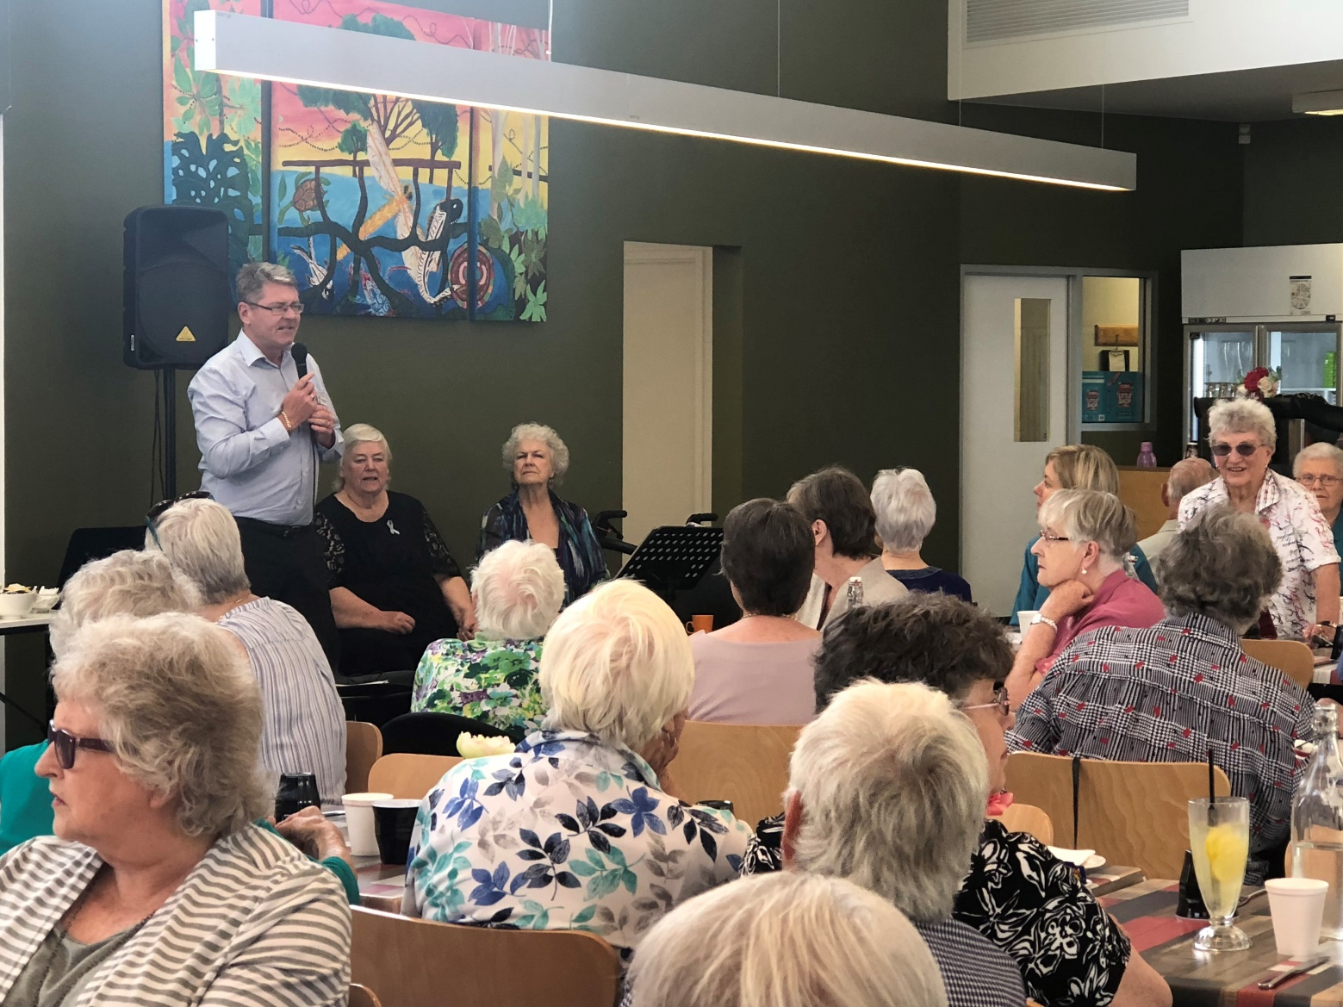

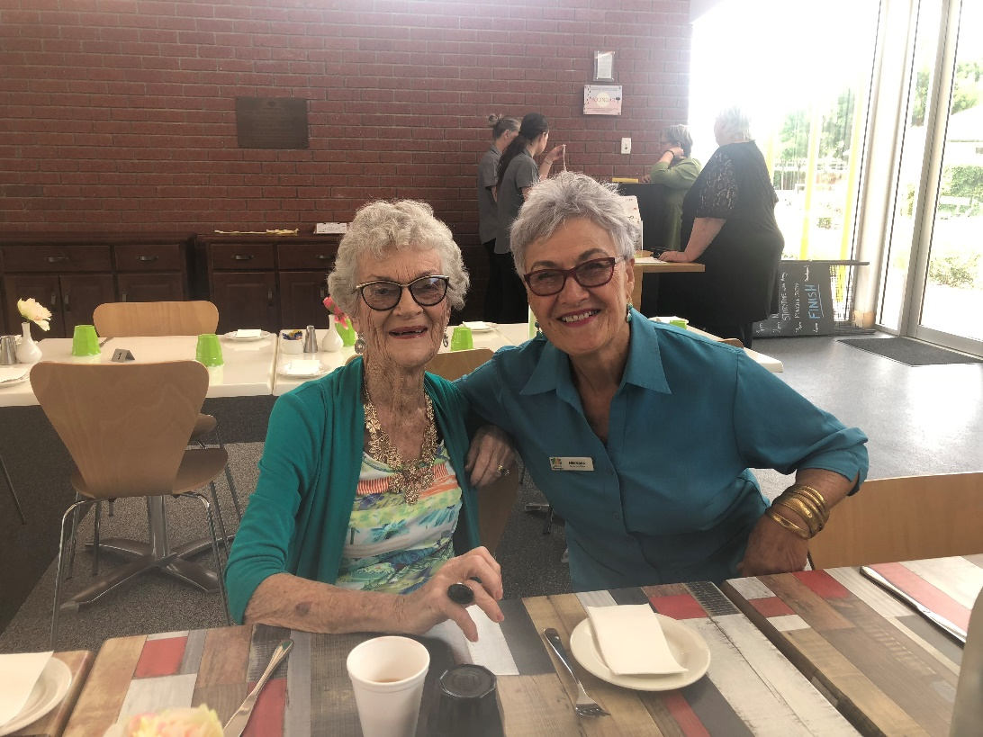

Margaret Williamson and Mereana enjoying a quiet chat.

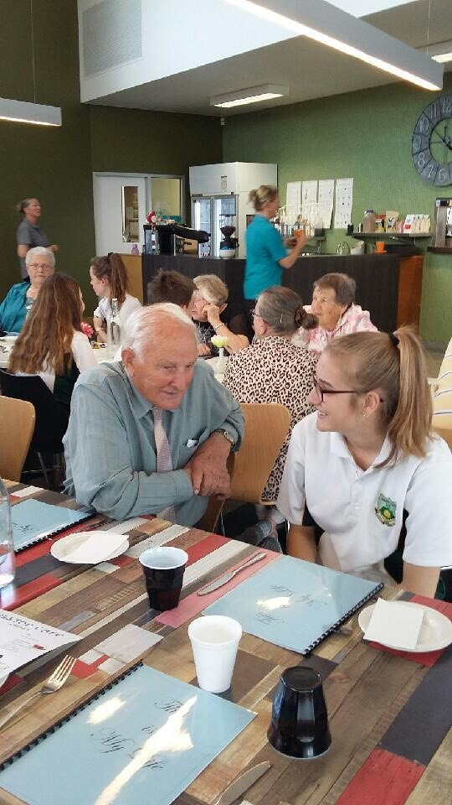

Bill Butler engaging with one of the students.

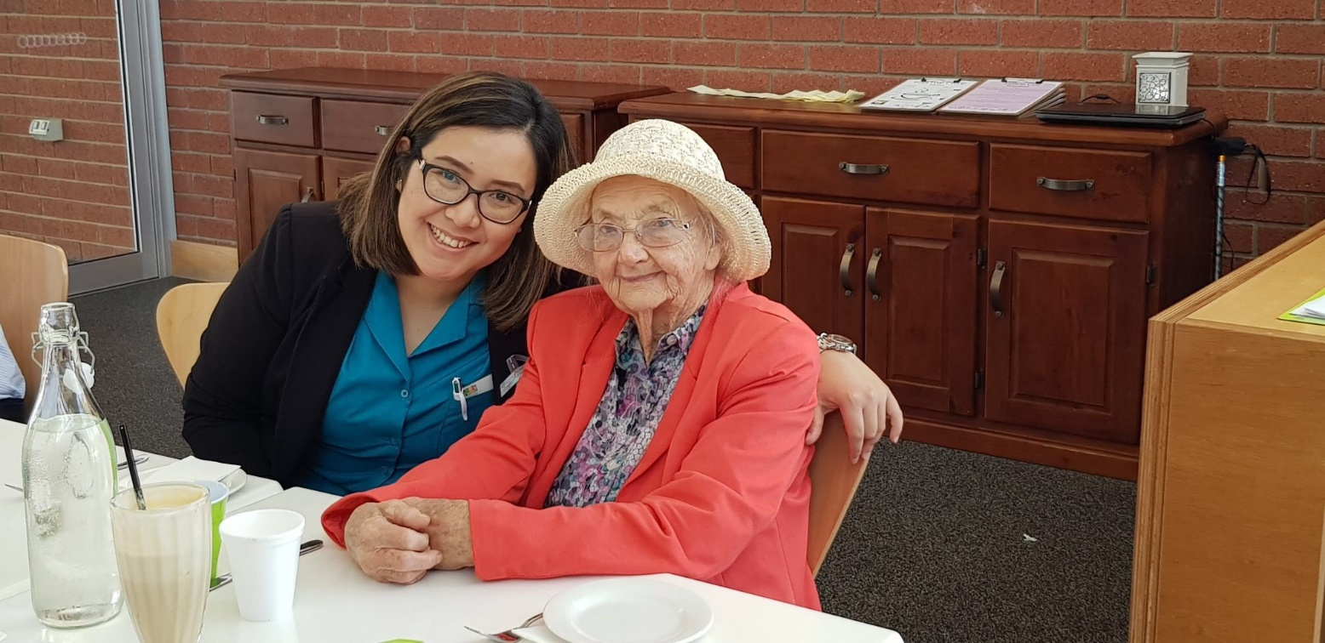

Joan Saunders and our Suzie sharing a moment.

About Dementia

Dementia is a collective name for progressive brain syndromes which affect memory, thinking, behaviour and emotion. Dementia is the leading cause of disability and dependency among the elderly. Although each person will experience dementia in their own way, eventually those affected are unable to care for themselves and need help with all aspects of daily life.

There are over 100 forms of dementia. The most well-known form of dementia is Alzheimer’s disease, which accounts for 50-60% of all cases. Other forms of dementia include vascular dementia, dementia with Lewy bodies and fronto-temporal dementia. Symptoms may include:

* loss of memory;
* difficulty in finding the right words or understanding what people are saying;
* difficulty in performing previously routine tasks; and
* personality and mood changes.

Dementia affects 50 million people worldwide, with a new case of dementia occurring somewhere in the world every three seconds. Dementia can also affect individuals under the age of 65 (young onset dementia). Greater awareness and understanding of dementia is important to challenge the myths and misconceptions that surround the condition.

There is currently no cure for most types of dementia, but treatment and support are available.

Early symptoms

Every person is unique and dementia affects people differently - no two people will have symptoms that develop in exactly the same way. An individual's personality, general health and social situation are all important factors in determining the impact of dementia on him or her.

Symptoms vary between Alzheimer's disease and other types of dementia, but there are broad similarities between them all. The most common signs are memory loss and the loss of practical abilities, which can lead to withdrawal from work or social activities. If you think that these problems are affecting your daily life, or the life of someone you know, you should talk to your doctor, or encourage them to talk to theirs.

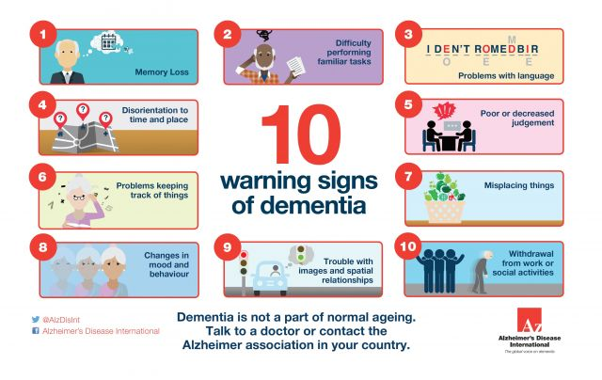

The most common early symptoms of dementia are:

Memory loss

Declining memory, especially short-term memory, is the most common early symptom of dementia. People with ordinary forgetfulness can still remember other facts associated with the thing they have forgotten. For example, they may briefly forget their next-door neighbour's name but they still know the person they are talking to is their next-door neighbour. A person with dementia will not only forget their neighbour's name but also the context.

Difficulty performing familiar tasks

People with dementia often find it hard to complete everyday tasks that are so familiar we usually do not think about how to do them. A person with dementia may not know in what order to put clothes on or the steps for preparing a meal.

Problems with language

Occasionally everyone has trouble finding the right word but a person with dementia often forgets simple words or substitutes, unusual words, making speech or writing hard to understand.

Disorientation to time and place

We sometimes forget the day of the week or where we are going but people with dementia can become lost in familiar places such as the road they live in, forget where they are or how they got there, and not know how to get back home. A person with dementia may also confuse night and day.

Poor or decreased judgement

People with dementia may dress inappropriately, wearing several layers of clothes on a warm day or very few on a cold day.

Problems with keeping track of things

A person with dementia may find it difficult to follow a conversation or keep up with paying their bills.

Misplacing things

Anyone can temporarily misplace his or her wallet or keys. A person with dementia may put things in unusual places such as an iron in the fridge or a wristwatch in the sugar bowl.

Changes in mood or behaviour

Everyone can become sad or moody from time to time. A person with dementia may become unusually emotional and experience rapid mood swings for no apparent reason. Alternatively a person with dementia may show less emotion than was usual previously.

Changes in personality

A person with dementia may seem different from his or her usual self in ways that are difficult to pinpoint. A person may become suspicious, irritable, depressed, apathetic or anxious and agitated especially in situations where memory problems are causing difficulties.

Loss of initiative

At times everyone can become tired of housework, business activities, or social obligations. However a person with dementia may become very passive, sitting in front of the television for hours, sleeping more than usual or appear to lose interest in hobbies.

If you are experiencing any of these symptoms or are concerned about a friend or relative, visit your doctor and discuss your concerns.

(Taken from Alzheimers Disease International, the Global Voice of Dementia website)

# FROM THE MANAGER’S DESK

Finish and start dates for the Christmas and January break

**Carers Support:** Will meet again on Monday 21 January 2018;

**Walk & Talk:** Will finish 21 December and resume Friday 18 January 2018;

**Banksia**: Will finish Monday 17 December and resume 4 February 2018;

**Cottage:** Will finish Friday 21 December and resume Wednesday 2 January 2018;

**Rivergum:** Will finish 19 December and resume 13 February 2018; and

**Tuart**: Will finish 12 December and resume 6 February 2018

Christmas closure

The Office will be closed from Monday December 24 at 4.30 pm until 8.30 am Wednesday 2 January 2019. During this time the personal care staff will be working every day. Domestic Assistance will continue except for public holidays. There will be no home maintenance services provided during this time.

A shopping service will be provided on Thursday 27 December.

If you are due for a service during the week between Christmas and New Year and are going to be away during this time, can you please call the office as soon as possible to cancel your service as this allows us to manage staff rosters efficiently.

If you would normally go shopping on Thursday 27 December either on the shopping bus or one on one and don’t wish to go, can you please call the office to cancel the services as soon as possible.

It would be appreciated if you could notify us of cancellations of any service as soon as possible during the holiday season of December and January.

Privacy and Confidentiality

Narrogin Regional Homecare is committed to protecting your privacy and confidentiality. We comply with the *Privacy Act 1988, Privacy Amendment (Enhancing Privacy Protection) Act 2012* and the Australian Privacy Principles.

**To ensure your privacy:**

* Client files and other information are securely stored;
* We only collect information about Clients that are relevant to the provision of support and we explain to Clients why we collect the information and what we use it for;
* We seek consent from Clients to, in an emergency, disclose personal information to other health service providers as appropriate to provide emergency care or services;
* We seek consent from Clients to provide access to Client records to government officials (or their delegates) in the conduct of quality reviews or the investigation of complaints. We advise Clients that these individuals are required to keep all information accessed through this process confidential;
* Information provided to government bodies regarding service provision (such as MDS data) does not identify the Client. If any information is provided to outside government agencies for data purposes we ensure that the information is de-identified and we make a note in the Client’s record what information was shared and to whom;
* Consent to share personal information can be withdrawn at any time by the Client;
* Clients can ask to see the information that we keep about them and are supported to access this information, if requested, within 30 days of the request. Information is provided in a format accessible by the Client. The Client can nominate a representative to access the Client’s records held by Narrogin Regional Homecare;
* All information relating to Clients is confidential and is not disclosed to any other person or organisation without the Client’s permission;
* We only share information when it is necessary to ensure appropriate support is delivered and only with the Client’s permission/consent beforehand;
* The provision of information to people outside the service is authorised by the team leader;
* We do not discuss Clients or their support with people not directly involved in supporting them;
* Our organisation takes steps to correct information where appropriate and regularly review Client information to ensure it is accurate and up to date;

Reviews are always conducted in private with the Client and the assessment officer unless the Client

* consents to their carer, advocate or other person being present;
* During Client reviews the assessment officer asks the Client about any particular privacy requirements they have, such as their preference for a male or female support worker. This information is noted on their assessment form and on the support plan;
* Any discussions between staff about Clients are held in a closed office;
* Clients are supported by us should they have a complaint or dispute regarding our privacy policy or the management of their personal information;
* Any references to individual Clients in meeting minutes refer to the Client by initials only or another unique identifier, such as their Client number;
* We destroy any personal information, confidentially, that we hold regarding our Clients when the information is no longer necessary to provide support.

Anyone can be happy when they get what they want; the challenge is to stay grateful and peaceful even when the world around you feels crazy and dangerous and horrible.

Elizabeth Gilbert

When we are no longer able to change a situation, we are challenged to change ourselves.

Viktor Frankl

We have thousands of opportunities every day to be grateful: for having good weather, to have slept well last night, to be able to get up, to be healthy, to have enough to eat...There's opportunity upon opportunity to be grateful; that's what life is.

Br. David Steindl Rast

*May the true meaning of the holiday/holy season fill your heart and home with many blessings. Wishing you much happiness today and throughout December.*

*Kindest regards*

*Lynne and the Narrogin Regional Homecare Team*



**Narrogin Regional Homecare**

Jessie House, Clayton Road, Narrogin   
(between the Leisure Centre and the Hockey Field)   
PH: 9890 0700  
Email: mccs@narrogin.wa.gov.au

**www.narrogin.wa.gov.au**