august Edition

# Sheoak and Rivergum Groups

Twice a week on Wednesdays and Fridays we hold group activities in the cottage.

We have a bus that can come and pick you up and then take you back home in the afternoon.

We provide morning tea, a hot home cooked lunch and activities. This is a chance for you to socialise with other people in a safe, warm, comfortable environment.

Ask us about the cost and our activity program. If you are interested in attending please call us on 9890 0700.

*Please note: you are required to have an assessment to determine your eligibility to join this social support group, we can help you organise that.*

# Carers Support Group

Are you caring for a loved one or relative and would be interesting in meeting up for a cuppa and a chat.

Our Carers Support Group meets once a month at our cottage in Jessie House from 2pm to 4pm with our next meeting on the 15th of August.

If you would like to chat to someone before you come, feel free to call Wendy on 9890 0700

Come along and say hello and if you are interested in joining and not already registered carer we can help you join. This is a free service for people and afternoon tea is provided.

Next meeting dates:

* 15th August
* 19th September
* 17th October.

# Tell us what you think!

Do you have any idea or suggestion for improving our services?

Do you have a concern or want to know how to make a complaint?

You can ask one of our friendly staff for a form, come into the Office or give us a ring on   
9890 0700.

We love to hear from you and are always looking for ways we can improve our services.

# Client Transport

Clients can access transport to medical appointments once being approved for this service.

So as to assist us in the office please let us know as soon when you have booked your medical appointment so we can organise transport.

We prefer at least one day’s notice to ensure we have a car and driver available. If we are unable to assist, we will let you know so you can make other arrangements.

# From the Manager’s Desk

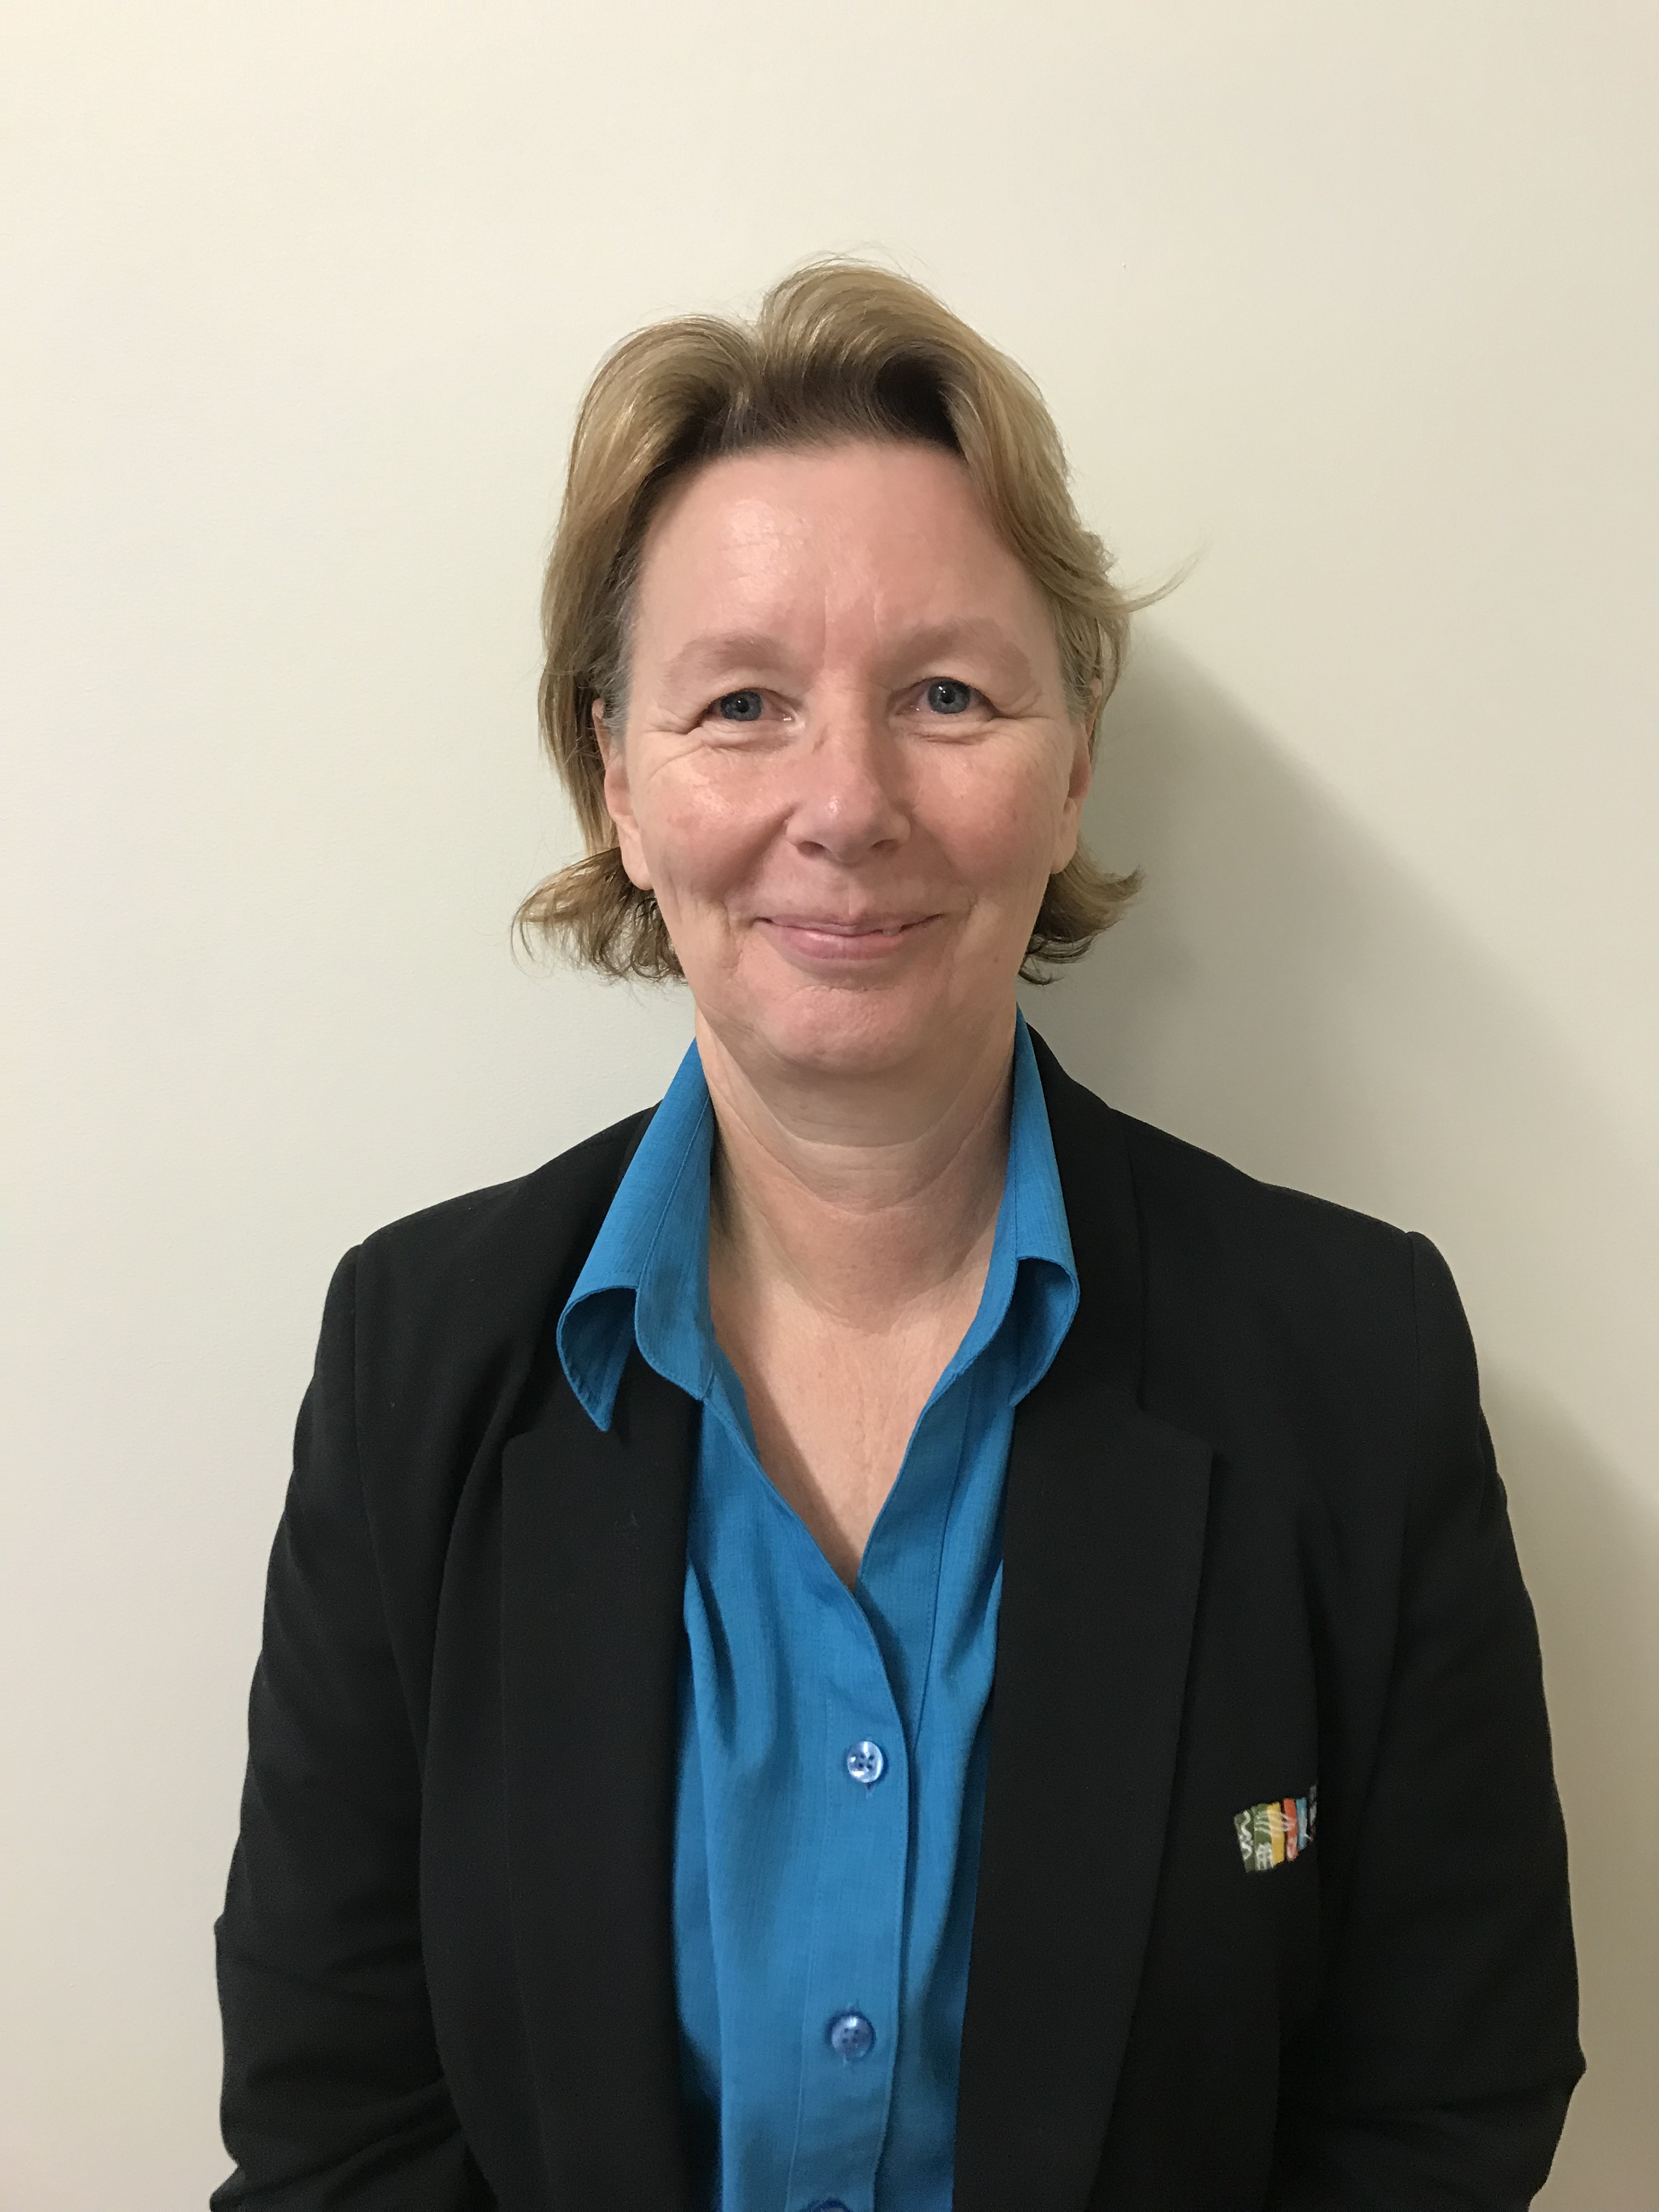

Hi everyone, I’m Wendy Le Bechee, and thank you for the warm welcome I have received since taking over the reins from Lynne who has now left to enjoy time with her family and retirement.

It is so nice to see the sun shining, even if the days are cold, so I hope you are all keeping warm especially during this flu season.

We are fortunate enough to be able to offer a wood chopping service and will try and do this as part of your regular service if you have been approved for this. If you know you are running low on of chopped wood please let us know as soon as possible so we can arrange the service for you.

Planning Day

We had a Planning Day recently, which was held in the Town Hall. Thank you to those that attended. We love hearing your ideas and suggestions so please feel free to let us know if you have any.

Charter of Rights

The Australian Government has updated the Clients Charter of Rights which you will all be asked to sign. This is to acknowledge that you understand your rights as a client and how to let us know if you have any concerns. If you have not already received this, it will be posted out shortly with a pre-paid return addressed envelope.

Flu Season

The Flu season is well and truly upon us again. Flu vaccines are free for over 65’s and give a high level of protection and can also help reduce your symptoms.

Keeping up your fluid intake can also help.

# Client Services

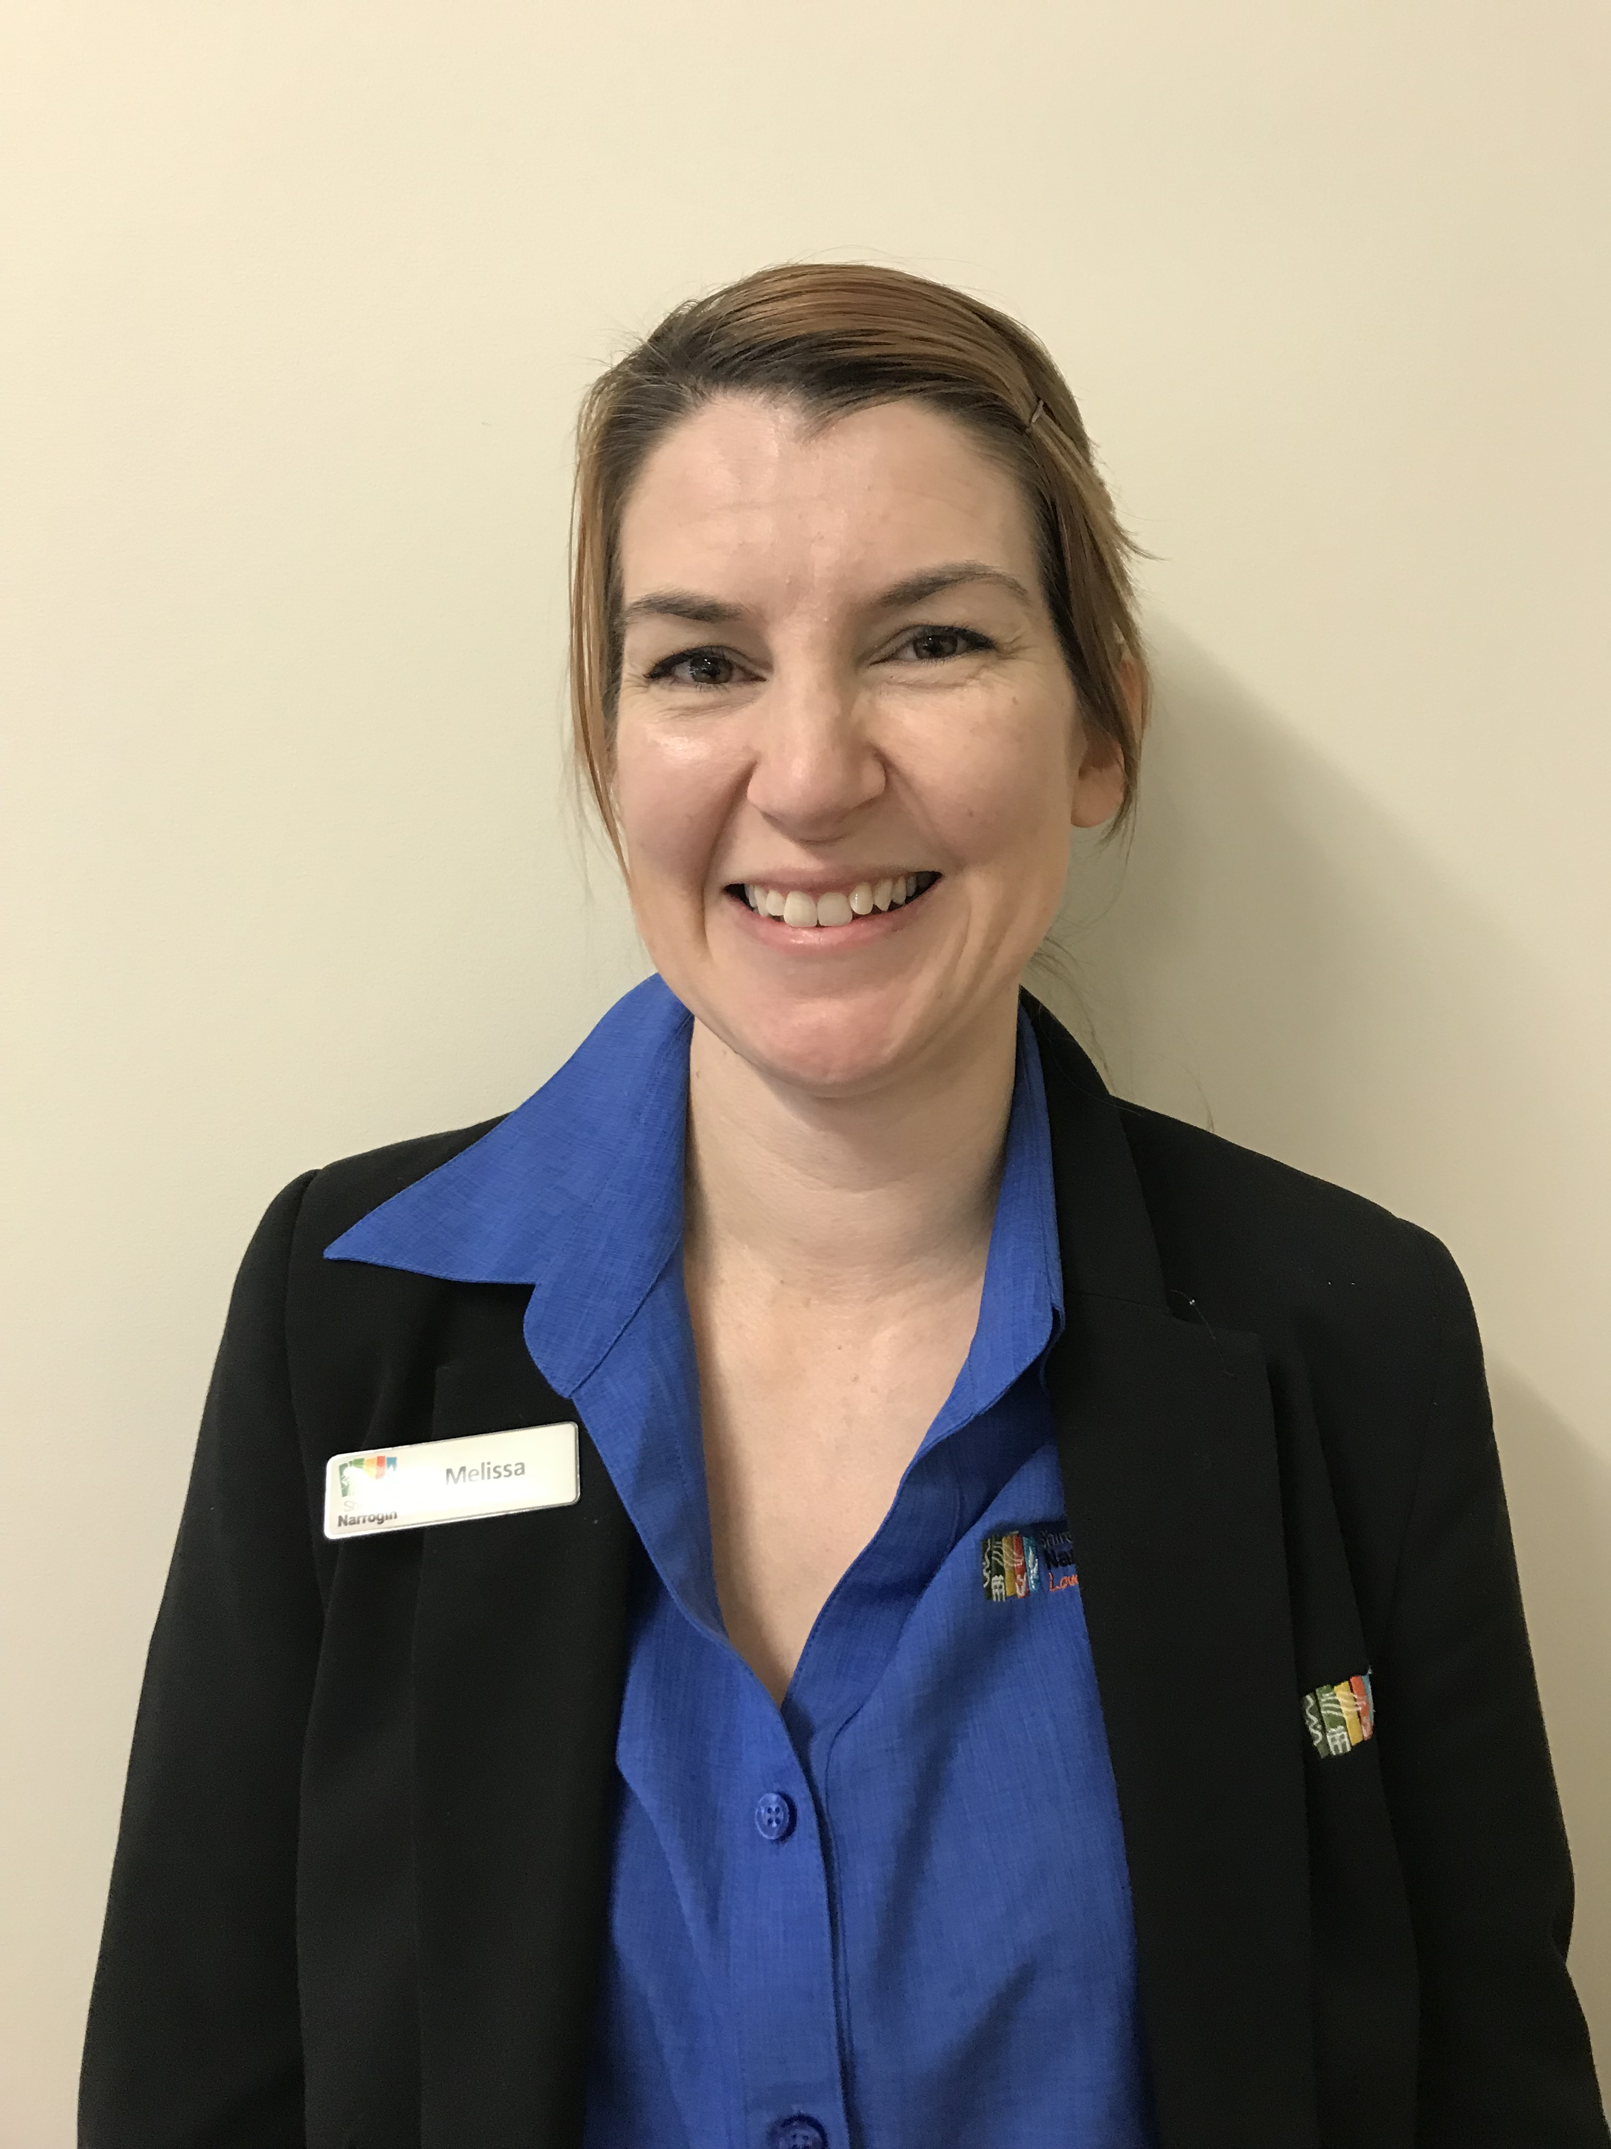

Hi, my name is Melissa Sullivan and I am acting Client Services Officer at Narrogin Regional Homecare. In my role I am responsible for ensuring that the services you receive from us are just right for you.

I can assist you to get in contact My Aged Care and get the assessment process started. Once you have been approved for services, we will come to you and have a chat and plan together how best to help you and how we can help you to stay safe and independent in your own home.

We can also assist with Domestic Assistance, and Social Support either in your home or in Jessie House cottage including home maintenance and personal care.

Currently we are doing our annual reviews. This means we will soon be coming to visit you to ensure the services we are delivering meet your needs.

I am looking forward to meeting you soon. Feel free to call me during business hours on telephone 9890 0700.



# Wattle Group Outings

Wagin Duck @ Game

Friday, 16 August. Pick- ups commence 9.00am & Leisure Centre 9.20am.

This family-owned duck and game enterprise provides free-range ducks to high-end restaurants all over WA. The birds bred here are free to roam during the day and penned at night. Join us on a tour of this intriguing Poultry Farm. After the tour we will have lunch in Wagin which will be at your cost of $25.00.

Williams CRC – Quiz/bingo and a light lunch

Wednesday 28th August - **Pick up from 10.00am & drop off approxroximately 3.30pm.**

Come and join seniors from Williams for a light lunch and get together, meet old friends or make new ones. Cost $28.00 (for catering purposes names and money to Mereana by 22 August).

Kings Park Festival

Tuesday 10 September.

See amazing spring displays of wildflowers and take part in the many events on offer, guided tours and talks, photography displays, wellness events and many outdoor exhibitions and for native gardening enthusiasts the famous Friends of Kings Park native plant sale. Lunch at Kings Park.

Perth Zoo

Wednesday 11 September Pick up will commence at 7.30 from the Leisure Centre 8.00am on Tuesday, 10 September.

Drop off approximately 5.00pm Wednesday, 11 September.

See the new additions of the Perth Zoo. White cheeked baby Gibbon “Lulani”, African Painted Dog puppies and Komodo Dragon re-vamped enclosure.

Your accommodation on Tuesday night will be at The Kings Park Motel. An evening meal is to be enjoyed at the Cambridge Forum International Food Court at your own cost. A continental breakfast in your motel rooms will be provided the following morning.

Cost $180pp includes accommodation, continental breakfast, morning teas, Zoo entry and guided tour on the Zebra bus. Two lunches and one evening meal is at your own cost.

To secure accommodation all money must be paid to the office by Thursday 26 August.

Future events

* Pinjarra Alcoa Refinery
* Melbourne Cup Luncheon
* Seniors Week
* Cherry Festival
* Christmas Lunch
* Rarebits lunch in Darkan